3GPP TSG RAN WG1 Meeting #86 R1-166107
Gothenburg, Sweden, August 22 – 26, 2016

Agenda Item: 8.1.6
Source: Huawei, HiSilicon
Title: Synchronization and initial access mechanism in NR
Document for: Discussion and decision

Introduction
In RAN1 #85, a number of agreements were made regarding synchronization and initial access procedures. In particular:
Essential system information (MIB) should be decodable based on an identity parameter used for generation of search/synchronization signal (e.g. PSS/SSS)
- Name of identity parameter TBD (e.g. cell ID, hypercell ID, system ID)
RAN1 studies both multi-beam based approaches and single-beam based approaches for these channels/signals/measurement/feedback
- Initial-access signals (synchronization signals and random access channels)
- System-information delivery
- …
- Note: The physical layer procedure design for NR can be unified as much as possible whether multi-beam or single-beam based approaches are employed at TRP at least for synchronization signal detection in stand-alone initial access procedure
Based on these agreements, this contribution provides an overview on the following aspects on synchronization and initial access for NR: 1) initial access procedure, 2) initial access mechanism in mixed numerologies in an NR carrier and 3) some design principles for synchronization, system information delivery and random access procedure.

Initial Access Procedure
The initial access procedure in NR should take the following into considerations:
- Decoupling of the rigid association with a physical cell or TRPs in boundary-less radio access [1]
- Single-beam or multi-beam based approaches

It was proposed in [1] that the identity parameter associated with the generation of synchronization signal and system information be based on a logical entity (e.g. hypercell ID) instead of a physical node.
The initial access procedure, from the UE perspective, is shown in Figure 1. NR will support single-beam and multi-beam operations for initial access. UE will support multiple numerologies or single numerology transmission/reception. The procedure should be unified as much as possible at least from the UE perspective. That is, we should strive for maximum commonality in the UE access procedure between single-beam and multi-beam operations in boundary-less radio access, as well as between multiple numerologies and single numerology transmission/reception. The network can, based on whether it is single-beam or multi-beam, transmit the synchronization signals and physical broadcast channel in appropriate time-frequency resources. Further detail of beam-based access can be found in [2]. Upon completion of the initial access procedure, a UE obtains information on hypercell ID and a UE dedicated identifier that can uniquely identify the UE across coverage of a logical access entity [1].

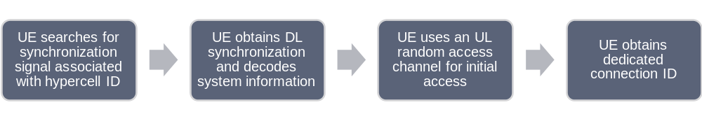
Figure 1: Initial access procedure from the UE perspective.

Proposal 1: The initial access procedure, from the UE perspective, should be unified as much as possible for multi-beam or single-beam based approaches, and for UE supporting single numerology or multiple numerologies.

Initial access mechanism in mixed numerologies in an NR carrier
In a system configured with mixed numerologies in an NR carrier, it is important to design mechanisms to ensure that a UE can access the system with reasonable complexity and latency. This can be accomplished by transmitting synchronization signals and essential system information in default numerology and frame structure configurations.
Default numerology parameters such as the default subcarrier spacing can be specified. Default frame structure configurations can include subframe length (e.g. derived from the subcarrier spacing). Network configures the transmission of the synchronization signals and essential system information from a set of default time frequency resources (e.g. similar to the frequency raster, OFDM symbol and subframe locations defined in LTE). This offers more flexibility in bandwidth allocation of different numerologies and frame structures while maintaining reasonable search complexity for initial access. The default frame structure can occur at the periodicity of the synchronization and physical broadcast channel carrying essential system information. Different default numerology and frame structure configurations can also be specified according to the spectrum range. In this way, a UE can search for synchronization signals and decode essential system information with the corresponding configuration for a particular spectrum range. An example is given in Figure 2. In this example the default numerology and frame structure configuration has a default subcarrier spacing of 15 kHz, subframe length of 1 ms and a periodicity of synchronization signal and physical broadcast channel of 10 ms defined for a spectrum range around 2GHz. The synchronization signals and essential system information can be transmitted in a TDM and/or FDM manner.
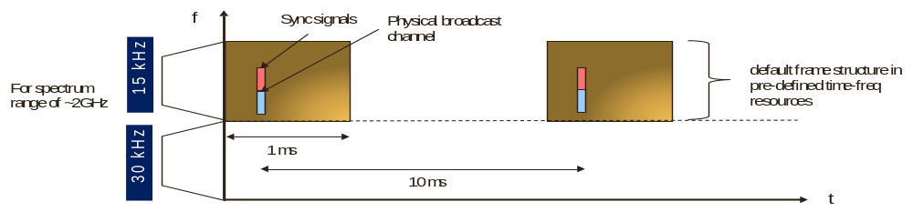
Figure 2: Default frame structure configuration in DL to facilitate UE initial access in mixed numerology.

Proposal 2: NR should support the use of at least default subcarrier spacing that is spectrum range dependent and default set of time-frequency resources on the downlink to facilitate initial access in mixed numerologies in an NR carrier.

Synchronization, System Information & Random Access Design Principles
The following design principles should be considered for NR synchronization and system information design:
- Synchronization signals and system information should be associated with a hypercell ID
- Beam-formed transmission of synchronization signals and system information should be supported
- NR should design different synchronization signals and system information delivery methods for different UE capabilities/types (e.g. UEs with different receive bandwidth capability such as eMBB/URLLC UEs and mMTC UEs).
- With default numerology and frame structure, as well as default set of time-frequency resources for carrying synchronization signals and system information, NR should support sharing of these functionalities between subbands of different numerologies that are multiplexed in frequency in an NR carrier.

In addition, NR should strive for commonality of synchronization signals design for standalone and non-standalone NR.
For random access, the following design principles should be considered for NR:
- Transmission of beam-formed random access channel over different resources from a UE should be supported
- If NR supports multiple UE capabilities/types (e.g. UEs with different transmit bandwidth capability such as eMBB/URLLC UEs and mMTC UEs), NR should design different random access channel formats for the different UE types
- Random access procedure and formats should strive for commonality to FDD and TDD

Proposal 3: NR should adopt the following design principles for synchronization signals and system information delivery:
- The identity parameter should be hypercell ID (i.e. a logical ID rather than an ID associated with a physical node)
- Beam-formed transmission should be supported
- Support different synchronization signals and system information delivery methods for different UE capabilities/types
- Support sharing of synchronization signals and system information between different numerologies that are multiplexed in frequency in an NR carrier
- Strive for commonality of synchronization signals design for standalone and non-standalone NR
Proposal 4: NR should adopt the following design principles for random access:
- Support beam-formed transmission
- Support different random access channel formats for different UE capabilities/types
- Strive for commonality of random access channel formats in FDD and TDD

Conclusion
In this contribution, an overview of synchronization and initial access for NR is discussed. The following are proposed:
Proposal 1: The initial access procedure, from the UE perspective, should be unified as much as possible for multi-beam or single-beam based approaches, and for UE supporting single numerology or multiple numerologies.
Proposal 2: NR should support the use of at least default subcarrier spacing that is spectrum range dependent and default set of time-frequency resources on the downlink to facilitate initial access in mixed numerologies in an NR carrier.
Proposal 3: NR should adopt the following design principles for synchronization signals and system information delivery:
- The identity parameter should be hypercell ID (i.e. a logical ID rather than an ID associated with a physical node)
- Beam-formed transmission should be supported
- Support different synchronization signals and system information delivery methods for different UE capabilities/types
- Support sharing of synchronization signals and system information between different numerologies that are multiplexed in frequency in an NR carrier
- Strive for commonality of synchronization signals design for standalone and non-standalone NR
Proposal 4: NR should adopt the following design principles for random access:
- Support beam-formed transmission.
- Support different random access channel formats for different UE capabilities/types.
- Strive for commonality of random access channel formats in FDD and TDD.

References
- R1-164371, “Considerations on New Radio Access Mechanisms in NR”, Huawei, HiSilicon, Nanjing, China, May 23 – 27, 2016.
- R1-166088, “Access mechanism for beam based approach”, Huawei, HiSilicon, Goteborg, Sweden, August 22 – 26, 2016.

